# **EXPERIMENT NO. 2**

To familiarize with selecting data from single table.

**Questions**

1. List all data from table deposite

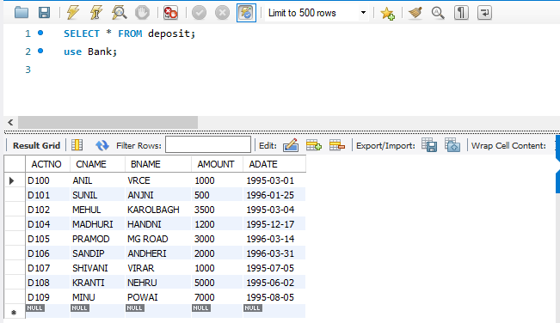

2. List all data from borrow

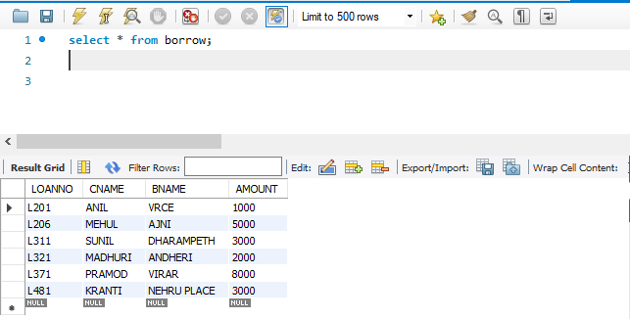

3. List all data from customer

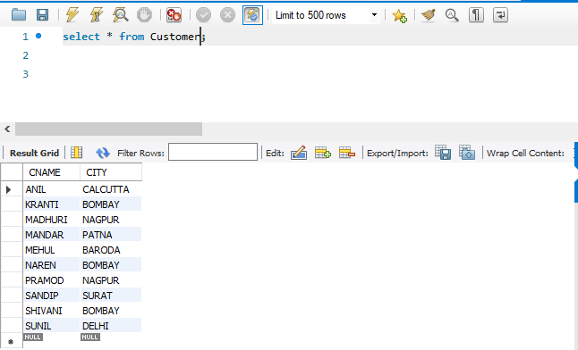

4. List all data from branch

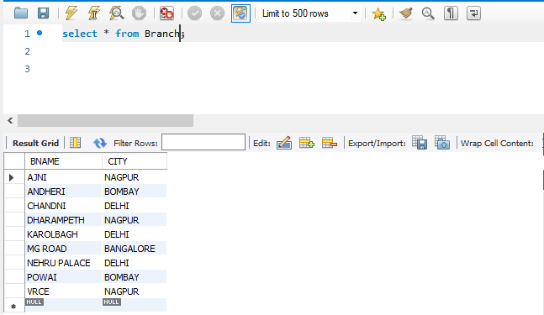

5. Give account no and amount of deposite

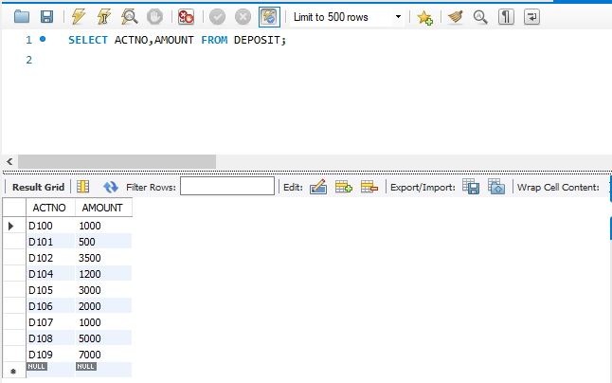

6. Give customer name and account no of depositors

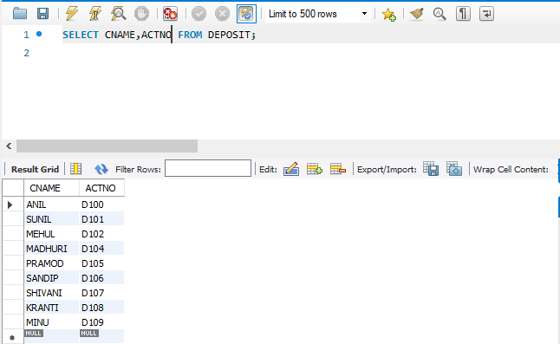

7. Give name of customers

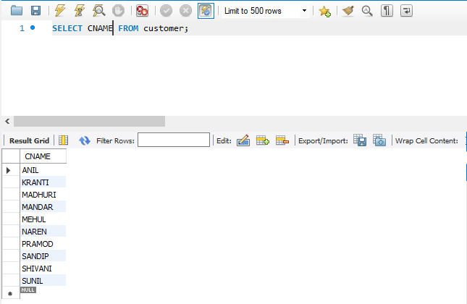

8. Give name of branches

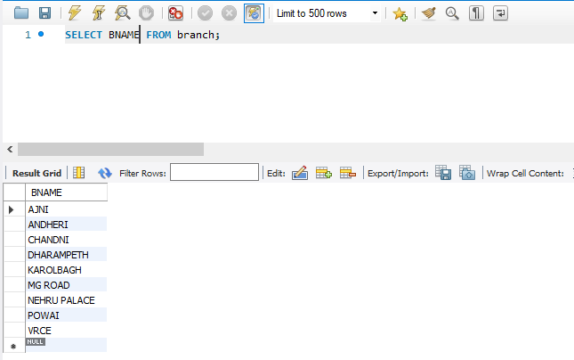

9. Give name of borrows

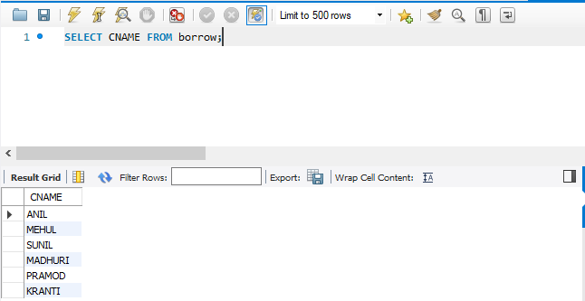

10. Give names of customer living in city Nagpur

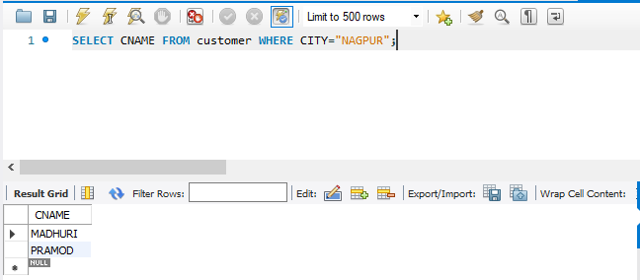

11. Give names of depositors having amount greater than 4000

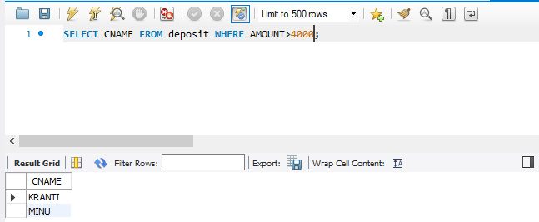

12. Give account date of Anil

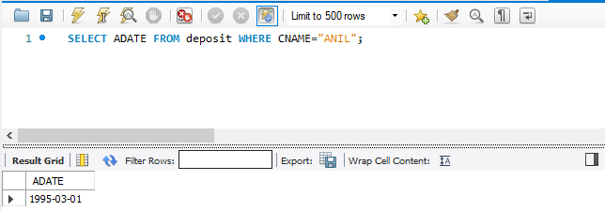

13. Give name of all branches located in Bombay

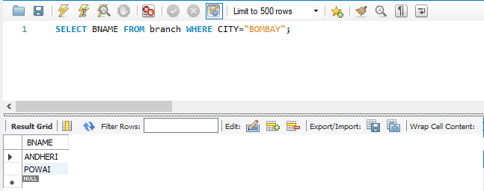

14. Give name of borrower having loan number l205

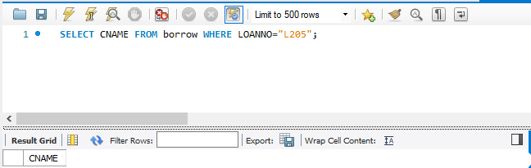

15. Give names of depositors having account at VRCE

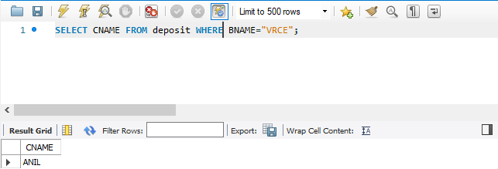

16. Give names of all branched located in city Delhi

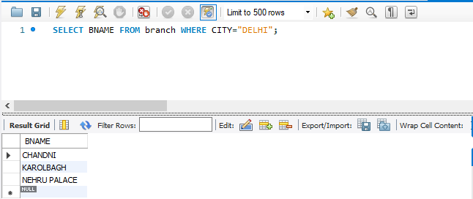

17. Give name of the customers who opened account date ‘1-12-96’

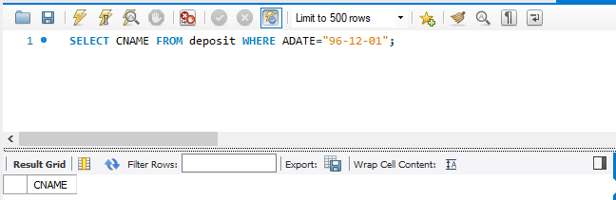

18. Give account no and deposit amount of customers having account opened between dates ‘1-12-96’ and ‘1-5-96’

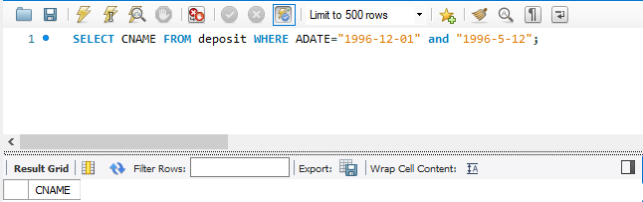

19. Give name of the city where branch KAROLBAGH is located

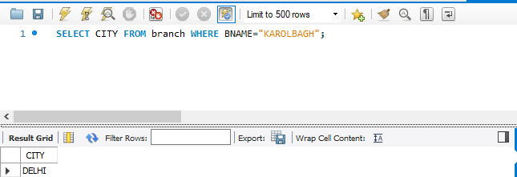

20. Give details of customer ANIL

